University of Puthisastra

## ICT

## Year 3 (Semester 2)

## Course: Dynamic Web Application

## Lecturer: Lypengleang Seang

# Project: CamboGolf Site

Members:

Chea Sopanharith (Leader)

Touch Teng

Thai Sereywathana

Yorn Ngornsreng

Soeun Sreykhuoch

SUOS Rothana (Deputy)

## ACKNOWLEDGE

We would like to express my deep sense of gratitude and convey thanks to everyone who helped us and supported us during the completion of this project and our research paper. First of all, we would like to express a deep sense of gratitude to our teacher and seniors for helping, guiding, and supporting us throughout our research completion. We also convey thanks to our committee members, Chea Sopanharith, Touch Teng, Yorn Ngornsreng, Soeun Sreykhuoch, SUOS Rothana for helping each other from time to time. We would like to acknowledge my department for providing the courses and great atmosphere that helped completely different chapters of this paper. We would like to thank to our lecturer, Mr Lypengleang Seang for supporting us and our concepts and for allowing us to do something the way we liked. Last but not least, we would like to thank our family members for their constant and unrelenting support towards our education. We would also like to thank our friends, without whom this project would have been impossible.

## INTRODUCTION

It is known globally that finding a job does not need you to walk around and find which job is suitable for you now. You can just browse online through out your phone or laptop using the internet. With the lack of advertising from employers or companies, it just become another face in the sea, and the advertisement does not reach a large group of people trying to find a job. In fast paced life of today when everyone is squeezed for time, the majority of people are finicky when it comes to applying or searching for a job outside. In the world full of technology, time is very value for everyone so saving much more from just finding your favorite position to work from online would be a please for everyone both the candidate and employer.

Online job posting website, such as BongThom, has gained huge popularity over the years because one can just apply for a job online and save enough time to do other important stuffs.

## SOFTWARE INTERFACE

This section lists the requirement that are needed to run the system efficiently. These are as follow:

Operating System: Window, Mac OS, or Linux

Browser: Chrome, Firefox, Opera, or Microsoft Edge

Integrated Development Environment: Wamp, Xamp, Mamp, Lamp

PRODUCT FUNCTION

The job portal website/system would have the following basic functions:

Display recent posted job

Allow user to post a job if they are logged in

Users can register and login

Admin ability to update, delete, or create jobs and users

## USER CHARACTERISTICS

The users of the job portal website/system, based on their roles, are user, employee, and employer (user) and the administrator (owner). These users are identified based on their experience and technical expertise.

Admin: The administrator is the owner of the web-based system. One must have a basic understanding of computer and internet. The administrator can perform the following functions:

View, add, update, and delete any job

Sign in/log in and sign out/log out using a username and password

User: The user of this job portal website are candidates who are looking for a job or an employer to post a job without featuring. These users are anyone who have basic understanding with internet and browsing. The user can perform the following functions:

View newly posted job and feature job

Post a job

Contact the owner

## PROJECT SITEMAP

## PROJECT DATABASE RELATIONSHIPS

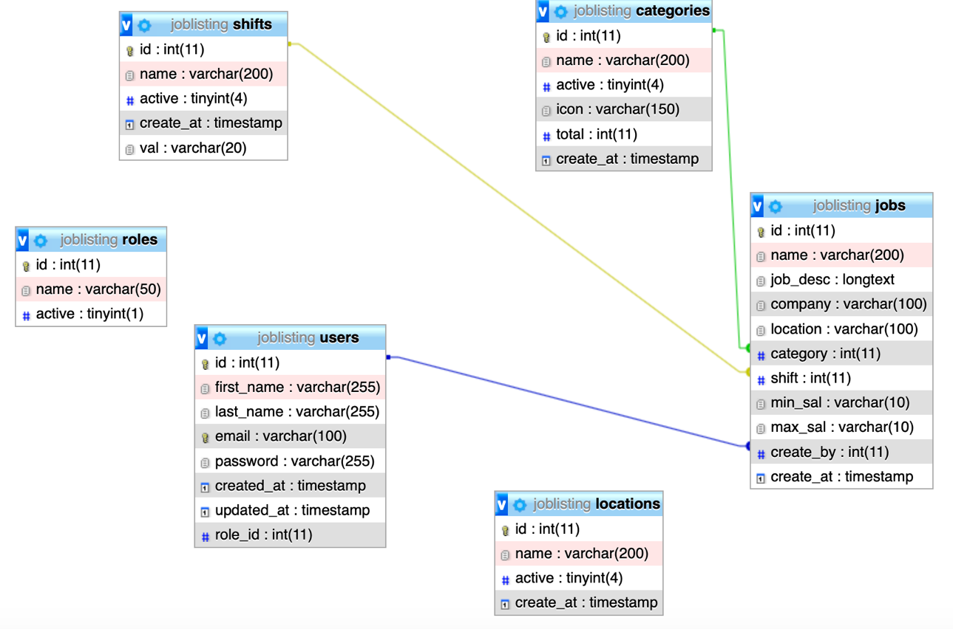

## PROJECT SETUP INSTRUCTIONS

1. Clone or download .zip

2. cd into Cambo_Golf_resort

3. Create .env file from .env.example

*Make sure you use your own mysql credentials*

4. Restore database from Cambo_Golf_resort/database/golfsite-db.sql

5. Run composer install

6. Run php artisan key:generate

7. Run php artisan serve

### **Default accounts for testing login**

Admin account:

email: [admin@example.com](mailto:admin@example.com)

password: admin

User account:

email: [user@example.com](mailto:user@example.com)

password: 110

## ROLES

Chea Sopanharith

* Role: Team Leader
* Duties: Code review and integration. Creating and submitting reports for teacher. Making sure each member performs their duty as well as give assistance when needed.

Suos Rothana

* Role: Team Deputy
* Duties: Review and give templating for admin(backend) UI and functions. Helping other members with integrating admin UI and functions.

Touch Teng:

* Role: Frontend (Client side) Developer

Soeun Sreykhuoch

* Role: Frontend (Client side) Developer

Yorn Ngornsreng

* Role: Backend (Admin side) Developer

Thai Sereywathana

* Role: Backend (Admin side) Developer

## CONCLUSION

This job portal website/system is made and designed with new and easy way for user to user and browse. It features functions for user to search, browse and look up for a job that suits them the best. Also, for the administrator and owner to control much more within the whole function in hand. With any mistakes and misfunction, I would like to apologize to lecturer.

## REFERENCE

Websites:

* <https://angkor-golf.com>

Templates:

* <https://html5load.com/free-golf-club-bootstrap-html5-template-golf-world-2/>
* <https://startbootstrap.com/themes/sb-admin-2/>